Project Statement: AI for Malware Analysis and Classification

1. Abstract
Malware classification is a crucial task in modern cybersecurity, enabling the efficient mitigation and response to threats. Traditional signature-based detection methods are slow to adapt to evolving malware families. This project proposes a deep learning-based malware classification system that leverages static and behavioral features of malware, such as opcode sequences, bytecode patterns, or execution behavior logs. By extracting meaningful patterns from these features, the system can automatically classify malware samples into known families with high accuracy. The proposed solution aims to improve the speed and reliability of threat detection in antivirus systems, enabling proactive defense against malicious software.

2. Functional Requirements
- FR1: The system shall allow authorized users to upload malware samples.
- FR2: The system shall extract static features (opcode or bytecode) or dynamic behavior logs from the uploaded samples.
- FR3: The system shall preprocess and vectorize extracted features for input to the deep learning model.
- FR4: The system shall classify the malware sample into one of the predefined families using the trained model.
- FR5: The system shall display the classification result and confidence score to the user.
- FR6: The system shall store a history of uploaded samples and results for each user.

3. Non-Functional Requirements
- NFR1: The system shall provide a user-friendly and intuitive web interface.
- NFR2: The system shall ensure the secure storage of uploaded samples and maintain data privacy.
- NFR3: The system shall respond with classification results within 5 seconds for a single sample.
- NFR4: The system shall be scalable to handle multiple concurrent users.

4. User Identification
- Admin: Manages the system, users, and monitors logs.
- User: Submits malware samples and views classification results.

5. Workflow of Each User

Admin Workflow
- Log in to the admin portal.
- View and manage registered users.
- Monitor system usage and logs.
- Update model or system configuration if required.

User Workflow
- Register and log in to the system.
- Upload a malware sample file.
- Select the type of feature extraction (opcode, bytecode, or behavior).
- Submit the sample for classification.
- View the classification result and download the report.

6. Use Case Diagram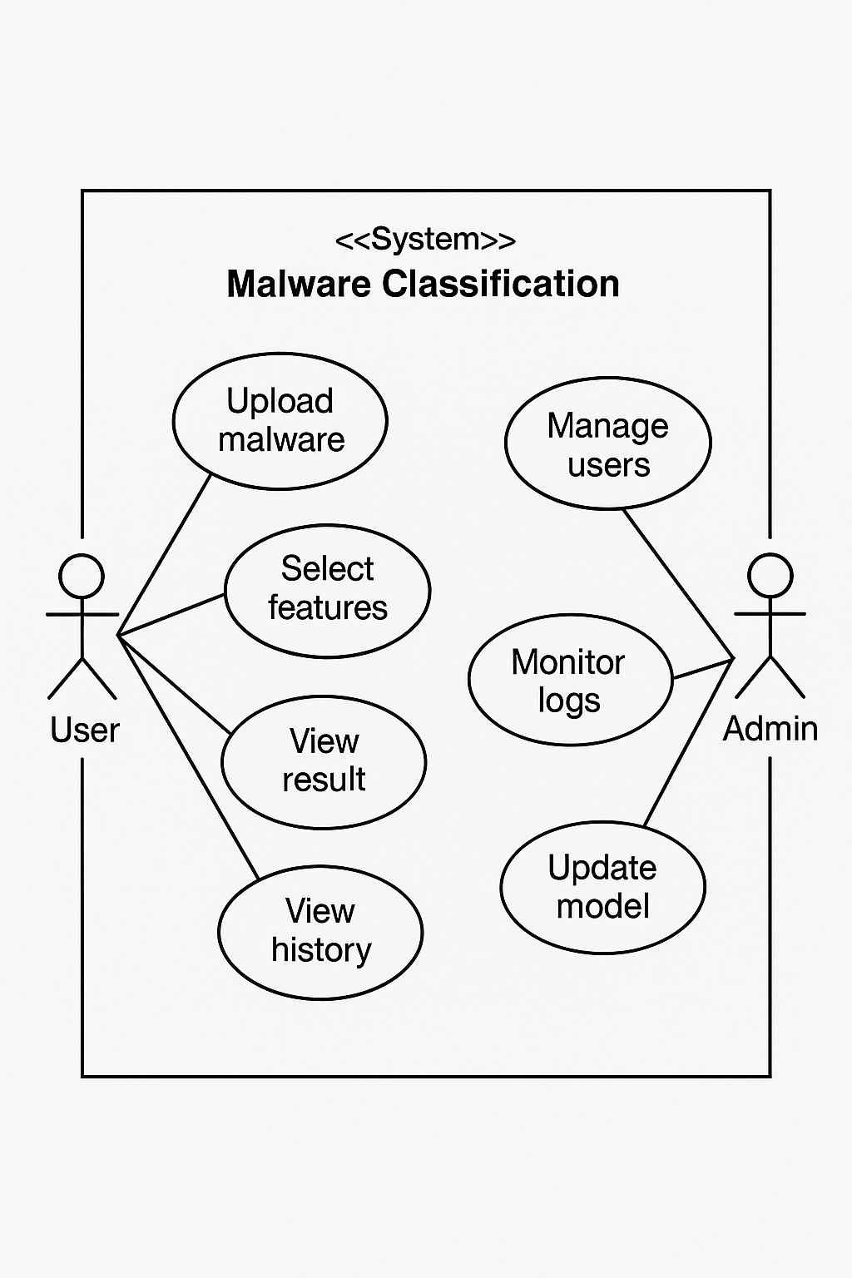

StarUml
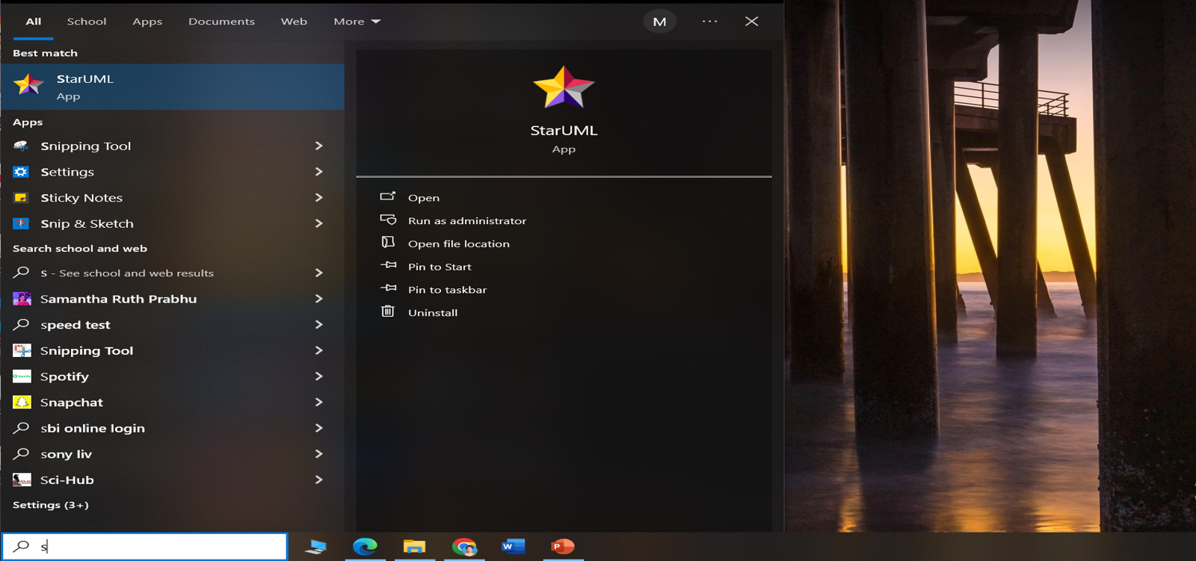
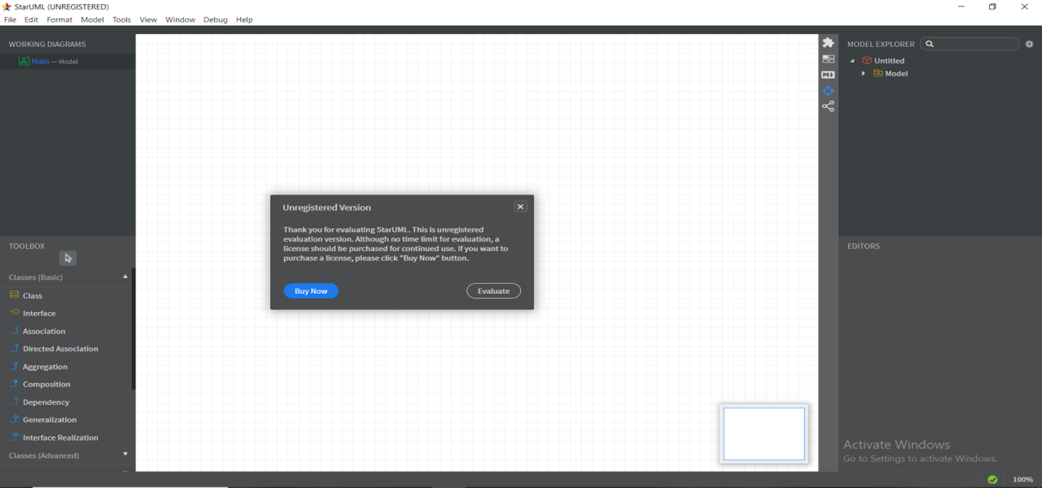

Gitbash
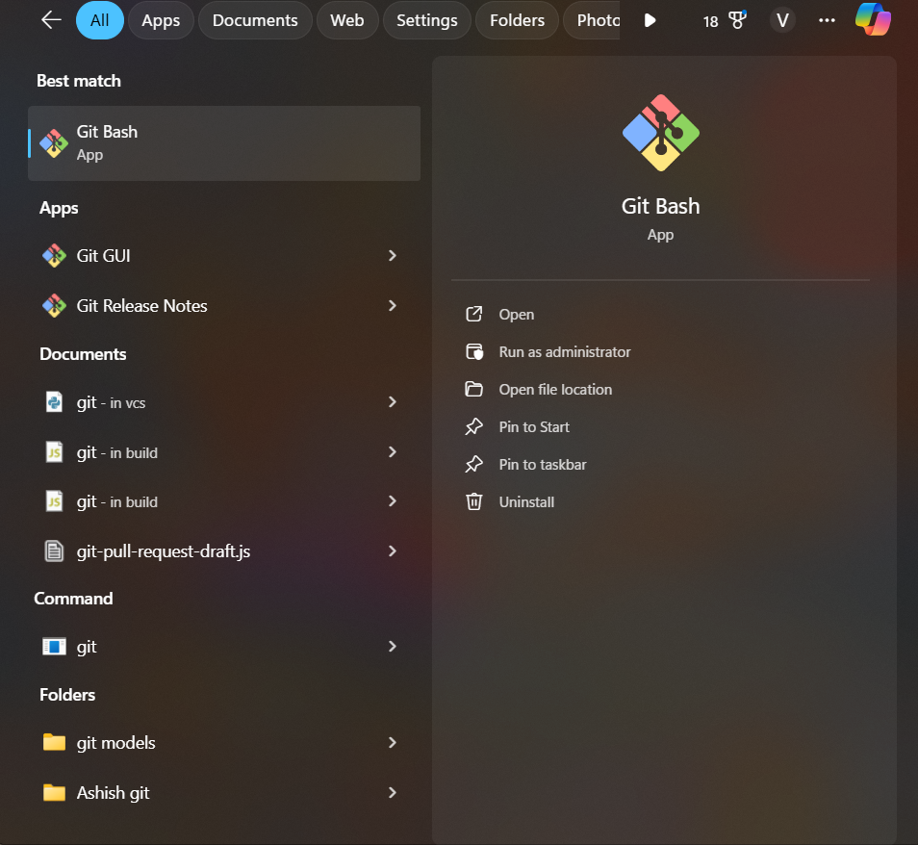

Github Account
